How to View, Edit, and Save a Spreadsheet file (with extension .XLS) when you don’t have MicroSoft Excel on your Computer

1. Log into Goggle using your Gmail account.
2. Click on the **APPS** icon
3. Click on the **Drive** icon

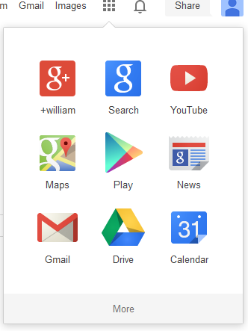

1. Click **Create**
2. Select **Spreadsheet:** A new, blank spreadsheet opens.

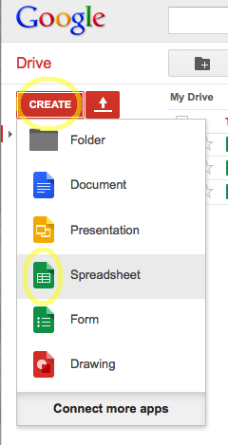

1. Within your browser window, click Google Drive’s **File** menu.  (**Not the File menu of your browser.**)
2. Click **Import**.

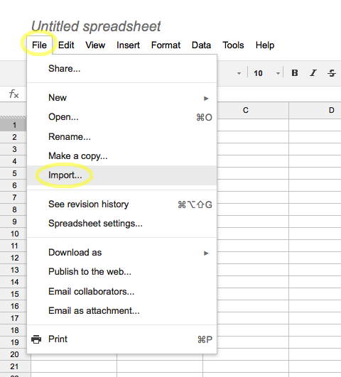

An Import dialog box opens within your browser window.

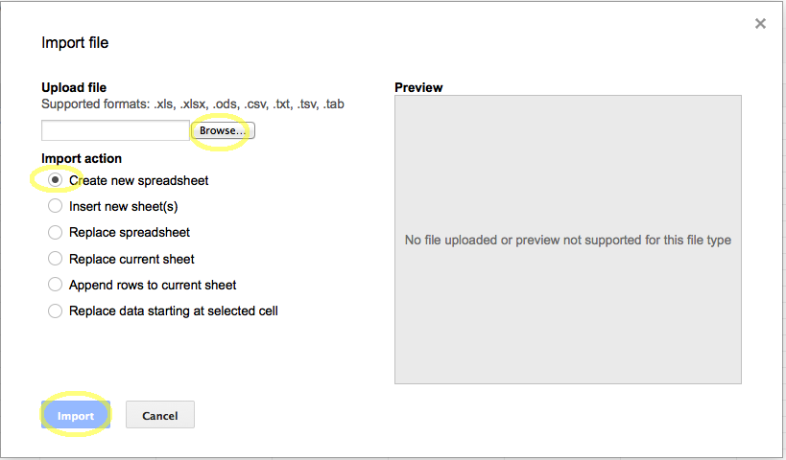

1. Under “**Import Action**” select **Create new spreadsheet.**
2. Click **Browse** and navigate to your existing Excel file (the one I sent in email that is downloaded to your hard drive).  The Import button changes to enabled.
3. Click **Import**. The Import File window appears.
4. Click **Open Now.** Thespreadsheet opens in Google’s spreadsheet program.

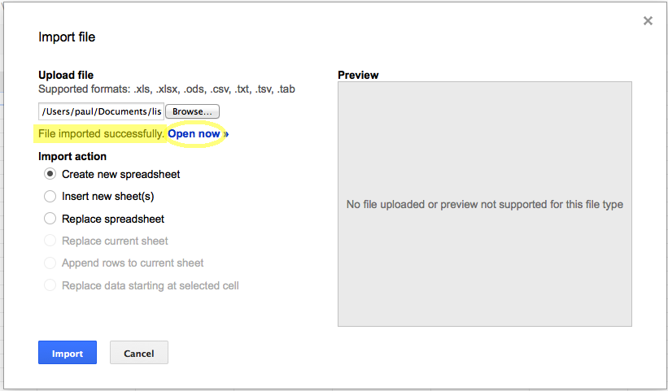

1. Edit this document as per the instructions.
2. When finished with your editing click the **Open Google Drive** button

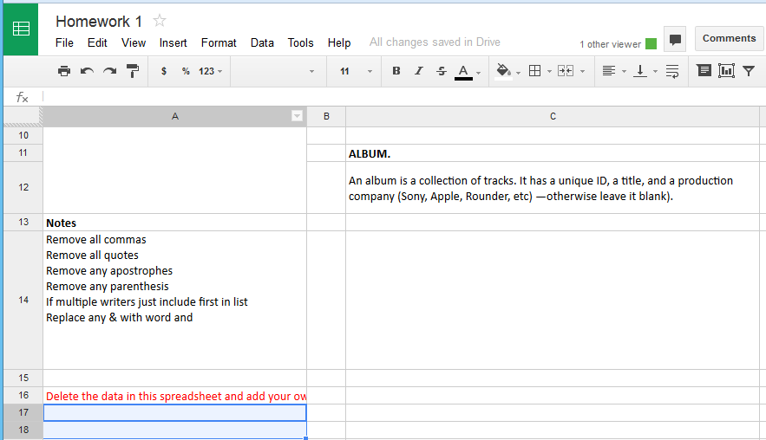

1. **Right-Click on the Homework** spreadsheet.
2. Click on **Download**. The Convert and Download window opens

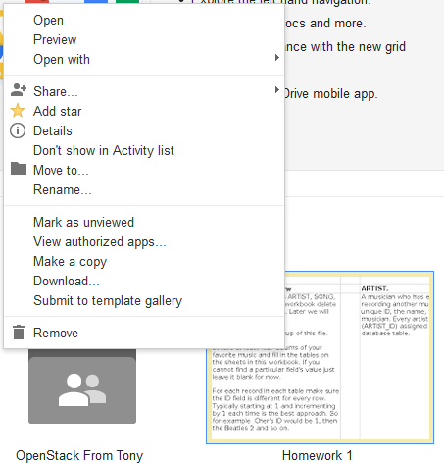

1. Click on **Download**.

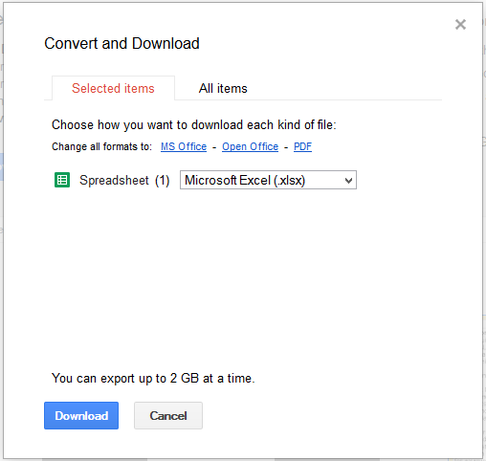

1. Click on **Save File**
2. Click **OK.** This saves the modified version of the spreadsheet on your hard drive

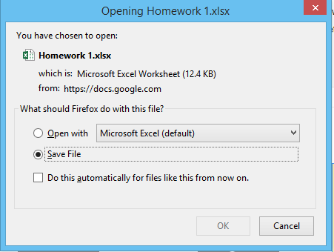

1. Email me this file now which is now on your hard drive